Overview
Students will be able to (SWBAT) evaluate and navigate the logistical challenges encountered by the Springfield Arsenal during the American Revolution. Throughout this simulation, participants will make key decisions that influenced the Armory’s effectiveness. Additionally, students will examine and match historical Springfield Armory invoices to meet the specific supply needs of the Continental Army.
This simulation will last four rounds where each decision participants make will either increase or decrease their available budget for hiring the arsenal staff in round 3 and producing material in round 4.

Facilitation requirements.
- Guide participants in selecting the Armory’s location from three historically accurate options.
- Oversee the design of the Armory’s building layout.
- Support participants as they use an authentic historical budget to hire and staff Armory workers.
- Facilitate the algebraic calculation of weapons and supplies required by the Continental Army for the Battle of Saratoga.
- Lead a structured reflection on the decisions made and their historical implications.

Welcome to the Springfield Arsenal!
The year is 1777 and the Revolutionary War is underway against the British. During this time there was a dire need to repair, store, and manufacture armaments and weaponry for the newly formed Continental Army. It is your job to make key decisions that will ensure the survival of the Springfield Amory and the very future of the United States. You will begin with a balance of $25,000 to begin your adventure and make key decisions about location, storage, and staffing for your armory. Each decision can determine either an increase or decrease to your budget. Good luck!
Your Advisors: Throughout this simulation, you will receive real-time correspondence and assistance from your advisors.
Advisor | Description
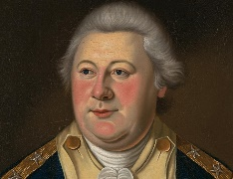  Henry Knox | Brigadier General Knox fought in many important battles, including Trenton, Princeton, and Yorktown, and became one of George Washington’s most trusted officers. After the war, he helped organize the new U.S. Army, manage relations with Native American nations, and establish early military practices for the young country. General Knox will provide information on the location of your Arsenal.
Col. Thomas Dawes  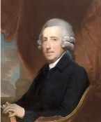 | Dawes was involved in both military and civic duties, helping organize militia forces and support the revolutionary cause in Massachusetts. After the war, he remained active in politics and law, serving in various public offices. Col. Dawes will provide information about ways to build your Arsenal.
John Bryant  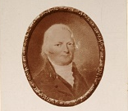 | John Bryant contributed to the development and production of firearms, helping the Armory maintain its role as a center of innovation in American military technology. His efforts supported both national defense and the growth of Springfield as an industrial hub. While less well-known than some historical figures, his work was vital to the Armory’s success during its early years. Bryant will provide you with key information about staffing your Arsenal.

Round 1: Determining the Armory’s Location
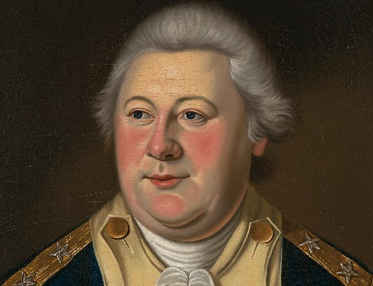
Henry Knox’s Draft Plan for an Armory, December 1776 (abbreviated and abridged)
“In the modern mode of carrying on a War there is nothing which contributes more to make an army victorious than a well-regulated & disciplined ammunitions. Magazines and Laboratories need to be formed in the right strategic locations. The commander officer will be empowered to begin work immediately.”

Your Options
Col. Jeduthan Baldwin’s suggestion of Brookfield Massachusetts – Located in Central Massachusetts, 30 miles east of Springfield, the area is sufficiently remote and difficult to access by an enemy. It is also reasonably safe for the storage of supplies and is currently the largest town in Western Massachusetts. However, operations will take three to four months to start. Colonel Baldwin is eager to return home there after directing fortification of the works at Long Island, Leachmor Point, and Ticonderoga, which included prescribing for at least one arsenal.

Knox’s suggest of Hartford Connecticut – May be more convenient than Brookfield because buildings already exist that can easily be converted into munitions factories. It has the great advantage of being at the headwaters of navigation for seagoing vessels on the Connecticut River. However, this advantage of being on navigable water comes with a serious drawback because enemy ships can also navigate the same waters.

Knox’s second option of Springfield Massachusetts – General Knox also suggests Springfield which sits on the Connecticut River, which allows to save on transportation through boat in several directions. secure against any attempts of the enemy since it is 20 miles above Hartford where the river is too narrow and shallow. May be easier to acquire timber, however few buildings suitable buildings for munitions exist and will need to be converted or created. One final note, the area has a surplus of available gunsmiths.

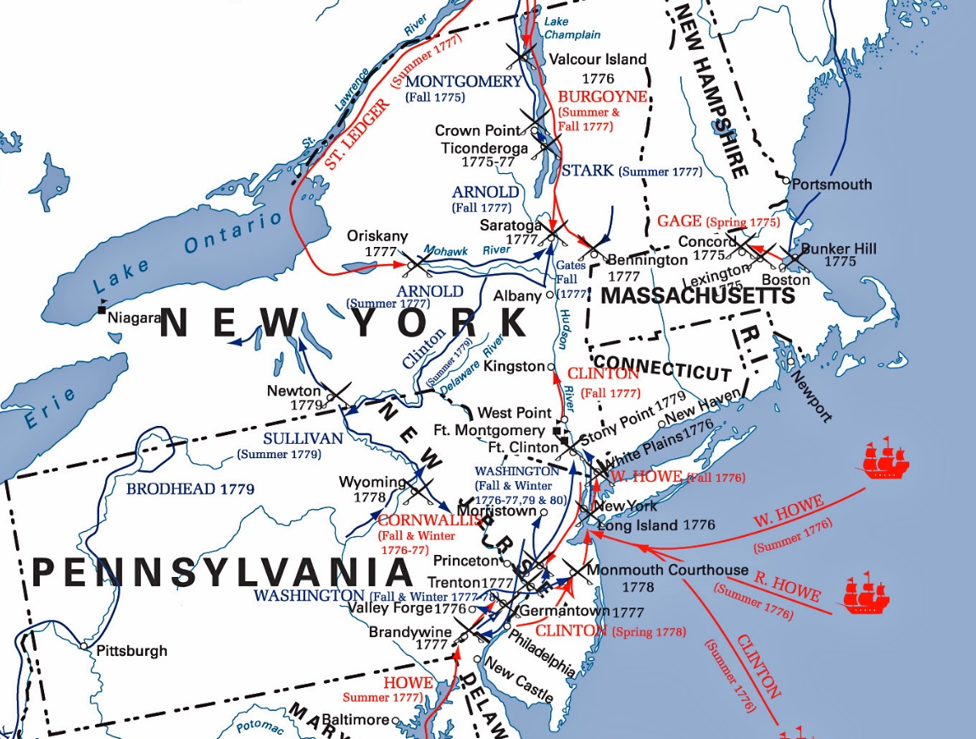
Map of Major battles and Locations of British Forces

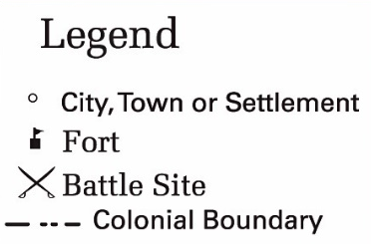

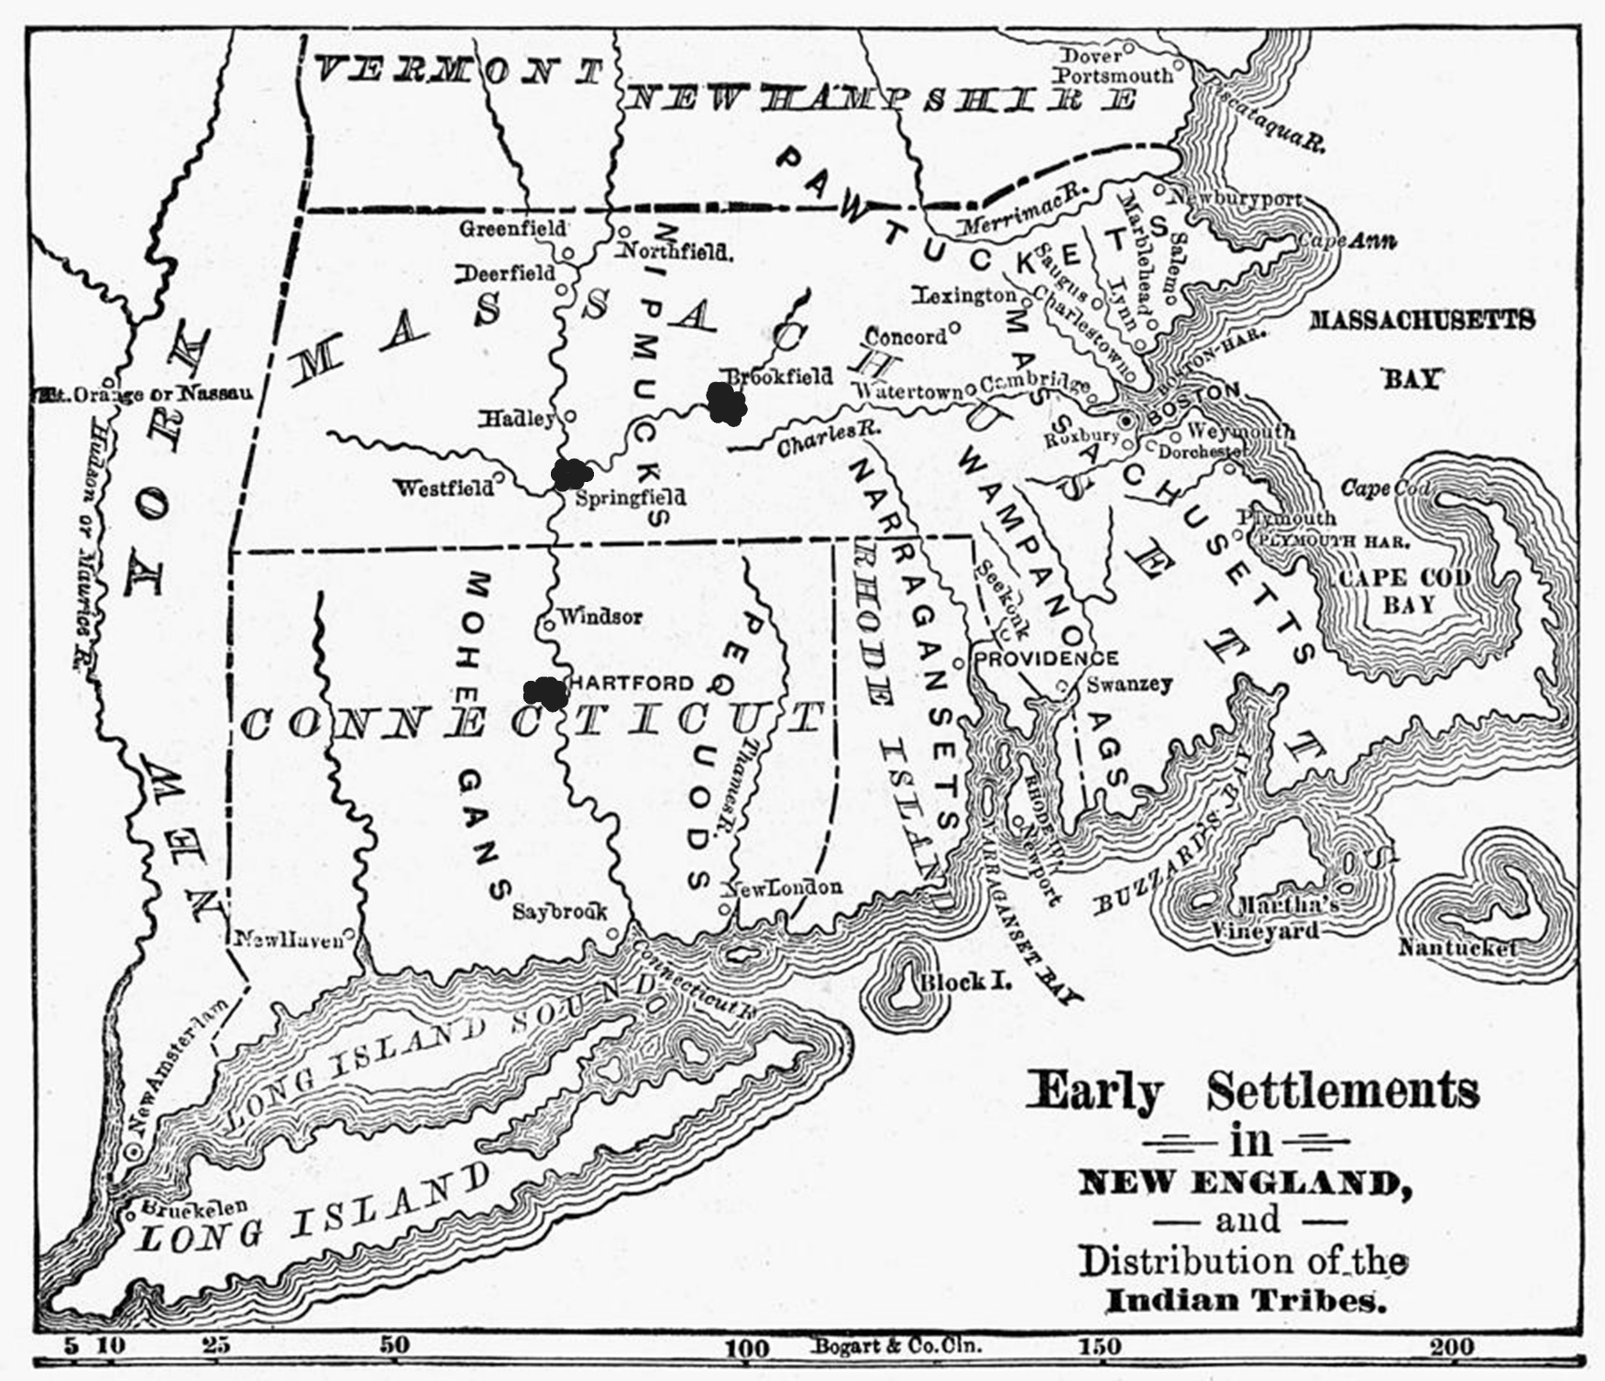
Potential Arsenal Locations

Round 1: Determining Armory Location
Brookfield Massachusetts
Pros | Cons

Hartford Connecticut
Pros | Cons

Springfield Massachusetts
Pros | Cons
Final Decision:
Starting Budget | $25,000
Budget change: | $
New Total Budget | $

Round 1: Results

Brookfield Massachusetts – Located in Central Massachusetts but will take three to four months to get operation up and running. Washington’s objects to Brookfield on the grounds of unsuitability of the location for various reasons, among them being the fact that it was too inaccessible and that it lacked facilities for water transportation
-$ 5,000 deduction from your staffing budget.

Hartford Connecticut – the great advantage of being at the headwaters of navigation for seagoing vessels on the Connecticut River. This fact, however, exposed it more or less to enemy attack from the sea, which at the time was a serious consideration, especially as the English were in possession of New York and could quite readily ascend the river as far as Hartford with the men-of-war of that period.
$0 , this decision neither helps nor hurts the Armory’s budget

Springfield Massachusetts – ., had the combined advantage of having water transportation facilities for small vessels with the fact that it was safe against attack by larger seagoing craft, and in addition, was on the regular direct line of travel between the Hudson River and Massachusetts Bay. Has vicinity of this town were a number of sites where waterpower could be obtained from the streams that empty into the Connecticut River, where saw mills were located, and the fact that timber useful for building purposes was, at that time, quite plentiful and easily obtained.
Add +5,000 bonus to your staffing budget.

